1. Viability question (Trypan blue)
   1. When counting cells after dissociation, we never really saw any ‘blue’ (i.e. dead) cells. It’s great if viability is 100%, but also wanted to convince ourselves that dead cells would appear blue.
   2. Two days after the experiment (Friday the 31st), I performed a viability test of the 4 cell and blastula stage embryos that had been sitting at 4C the whole time, thinking that there must certainly be cell death in those samples by now.
   3. I did 1:2 Trypan blue (20uL cells: 20uL Trypan) and observed tons of blue shmutz, and a few live cells. This blue schmutz was not observed on Wednesday during the experiment.
   4. My concern is that perhaps the dead cells are exploding due to the osmotic change from being diluted in trypan blue. Perhaps the live cells can handle the change, but dead cells can not? This would mean Trypan blue would not work great for viability, because it would be very difficult to observe a small number of ‘dead’ cells because there would just be some blue muck around - but at a much lower level.
   5. Questions: What do other folks who work with seawater species (e.g. ciona, urchins) do for viability? Is there any info out there for Trypan and salt water species? Maybe do a lower dilution? Maybe there’s a better dye?
   6. Images:

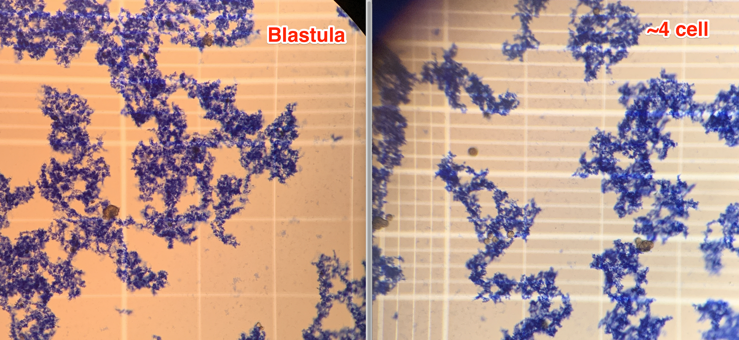

1. Fixative testing
   1. Would like to find a way to fix the embryo stages so that we can get high quality images of the samples, but not have to do it the same day as the experiment. Eddie give me some Dietrich’s and NBF fixatives to test
   2. I put 100uL of embryos (in seawater) into 400uL of fixative. I took samples at the 4 cell, 32 cell and blastula stage and tried both fixatives at each stage. On Friday I looked at the embryos quickly before exchanging the fix for 70% EtOH (spin then remove supe)
   3. Findings: Niether fixative kept the embryo shape. The 4-cell which usually have very defined edges were in more of a round ball shape. This shape change was less obvious with the blastula which is already quite rounded. The Deitrichs’ samples had some crystals associated with the embryos while the NBF had a lot of shmutz around, perhaps indicated that some of the cells had burst either in the fixative or in the 70%. I don’t think I looked close enough before swapping the fix to notice. Weirdly, one of the blastulas was still spinning in the sample. Yuck, zombie embryo.
   4. In short, neither fixative is perfect, but Deitrich’s seems a bit gentler. Will need to look up how other folks are using it with embryos to optimize the process. That would be worth trying again.
   5. Images:

